Hannah Johnson

Seaside Serenity

*“Designed for dives”*

# **Executive Summary**

# This project aims to create a socially conscious e-commerce retail store along with a shopping bag/packaging prototype that goes along with the target customer and mission of the retail organization. In order to achieve this goal, a PEST analysis of the retail organization will be conducted, specifically focusing on the stores' geographic location. Also, the target customer will be identified, and a private label will be created to accompany the organization. A Shopify store will be developed along with packaging to go with the brand. Completing these steps will ensure the success of the project and the creation of an e-commerce retail store.

# **Phase I**

A PEST Analysis is a tool that assesses a business's political, economic, social, and technological characteristics. This analysis will specifically focus on the geographic location where "Sands of Style," the retail organization I created, will conduct business. "Sands of Style" is a retail store that specializes in beachwear. According to Business News Daily, political factors examined in a PEST analysis include employment regulations, environmental factors, government policy, intellectual property protection, property rights, stability, tariffs, taxation, and trade restrictions (businessnewsdaily.com). The "Sands of Style" retail locations will be located explicitly along the West Coast in California. All merchandise will be created/produced in California, eliminating the possibility of trade restrictions because the business is strictly in the United States. The tax policy of the United States will affect the retail organization's cash flow because, according to the IRS, employment taxes such as social security and Medicare taxes must be withdrawn from the company when there are employees. "When you have employees, you as the employer have certain employment tax responsibilities that you must pay and forms you must file" (IRS, 2023). Government laws passed in general relating to businesses or small businesses may affect the retail organization, such as employment laws and advertising laws. According to the State of California Department of Industrial Relations, laws such as following the proper payroll guidelines and obtaining workers' compensation insurance must be followed (State of California, 2023).Regarding the stability of the "Sands of Style" stores' geographic location, the political environment is stable, and nothing materially will affect the business and its profitability because the company is strictly in the U.S., and there are no outside connections. Employment regulations such as minimum wage must be considered, "the minimum wage in California is currently $15.00/hr for employers with 26 or more employees, and $14.00/hr for employers with 25 or fewer employees" (State of California, 2023). The retail organization has over 25 employees, so the $15.00/hour minimum wage applies to the company.

“E” in the PEST Analysis stands for economic. When relating the financial issues that affect the geographic location, several factors are examined: access to credit, business investment levels, cost of living, economic growth or decline, exchange rates/interest rates, globalization, inflation, labor costs/workforce skill levels, market conditions, spending habits, and tax levels (Business News Daily, 2023). When focusing on inflation, the rate continues to increase, affecting the prices of the merchandise sold. Materials cost more money, so merchandise prices have to rise to earn a profit. Regarding the growth of the economy, according to CalMatters, the U.S. economy continues to grow, which conflicts with what economists initially thought. “A recent Public Policy Institute of California poll found that Californians overwhelmingly believe that bad economic times lie ahead, based in part on experiences with inflation in housing, food, fuel, and other living expenses” (Walters, 2023). There is a foreseen decline in the future for the economy as inflation continues to rise all over the United States; this is not just the state of California; every state has this issue, so it does not impact the retail organization that much. According to the Bureau of Labor Statistics, there was a 1.4% increase from last year for apparel regarding the Consumer Price Index in the West Region (2023). They will be equal in tax levels because the retail organization is only in California, and no other states or countries are involved. Globalization is not a worry in the case of the retail organization because the company is strictly in the United States.

"S" in the PEST analysis stands for social. Social factors consist of attitude toward work, consumer trends/tastes/fashions, diversity/inclusion/equity, division of wealth, education, employment patterns/job market trends, generational attitude shifts, the health of the population, population demographics, population growth rate, social mobility and lastly unionization (Business News Daily, 2023). Regarding the population growth rate, according to the Department of Finance in California, in 2022, there was a 0.35% decline in the state's population. This decline is "due mainly to sharp declines in natural increase and foreign immigration" (Newsom, 2023). The demographics of California's population involve the retail organization's target market: young women. Analyzing the amount of education residents in California achieve, according to Statista, 22.5% of the population graduates with a bachelor's degree. Regarding consumer trends, California does an excellent job as a state with following trends and keeping up with what is popular. The retail organization is always stocked with trendy pieces to catch the eyes of West Coasters. According to the Employment Development Department of California, the unemployment rate reached 4.7% in September (2023). This means many people are looking for jobs suitable for retail organizations.

“T” in the PEST analysis stands for technology. Technological factors include artificial intelligence, automation/robotics, cybersecurity/data protection, disruptive technologies, innovation, remote work, research/development, social networking, and tech hubs (Business News Daily, 2023). Artificial Intelligence is becoming more common and is used by businesses to help with social media and consumer insights. Social networking is a trendy way for corporations to advertise and generate sales in today’s age. Research and development would be beneficial to any company, as well as getting to know their target audience. Innovation is essential nowadays, so brands stay on top of what is happening with technological advancements. Remote work can be done within the retail organization, but regarding corporate jobs, such as marketing. Jobs such as sales need to be in person because people need to work at the retail organization to operate.

I chose California for the retail locations of "Sands of Style" to be in California because the state has a very diverse population regarding age, income, gender, etc. The retail stores' location is warm year-round, so the merchandise sold goes along with the weather, which aligns with my private label. The state is large, so the retail stores are spread out across the state, ranging from San Jose to San Diego, so the stores are accessible and convenient to many areas of the state's population, including the beach towns.

# **Phase II**

The retail organization “Sands of Style” and the private label “Seaside Serenity” target female customers. Specifically, these women will be young adults/mid-twenties ranging from the ages of 18-25. This age range will coincide with the styles of beachwear the store sells and what would be considered “trendy” to that population. The geographic location for these women will be California, specifically around areas such as Malibu and Laguna Beach, both beach towns, because the retail organization is a swimsuit retailer, and the stores are only located in California. These women will be making $120,000+ annually on their own. This income will allow them to afford the high-end swimwear sold in stores without having to look at the price tag too much. These women do not have children, so that they will invest money into more excellent merchandise. They do not have to worry about it getting ruined with possible stains or fear of their children getting ahold of it. The education these women have achieved is a bachelor’s degree or higher, reflecting the income they bring in. These women are active and enjoy hiking, running Pilates, and workout classes. Enjoying swimming and lounging by the pool is an interest; the women want to feel confident and look stylish at the same time. Self-care and traveling are other hobbies that women enjoy. Also, they believe it is essential to fuel your body with healthy foods and the idea that Vitamin D intake will boost your mood.

# **Phase III**

The merchandise category that the private label "Seaside Serenity" will sell will be swimwear. The swimwear styles will range from bikinis to one-pieces and everything in between. The logo for the label is a circular design with a light font curved around a seashell. The color scheme of the logo involves different shades of blue and tan. I chose the name for the company because company names with alliteration incorporated are catchy. According to Tungsten Branding, "One of the stickiest techniques in company naming is the use of alliteration (both words starting with the same letter)" (Davis, 2023). The words "seaside" and "serenity" gave off the relaxing/beach mood I sought. The colors in the logo reflect the shades of the beach, which illustrates the company's purpose. Since the target consumer enjoys lounging by the pool and swimming, these traits would appeal to the consumer. The brand's core focus is for women to feel comfortable while swimming in durable, stylish pieces. The slogan for "Seaside Serenity" is *designed for dives.*

The additional building blocks I created for the private label “Seaside Serenity” were a shipping box, a bathing suit bag, and a different logo. The shipping box I started is for retailers when they place orders. The box will include custom tissue paper from EcoEnclose (made from 100% paper fibers) and will be made from cardboard, a recycled material. The bathing suit mesh bag is produced from organic cotton and comes with all bathing suits purchased from the retailer. Lastly, the secondary logo I created is based on the brand’s slogan and is used on packaging and marketing materials.

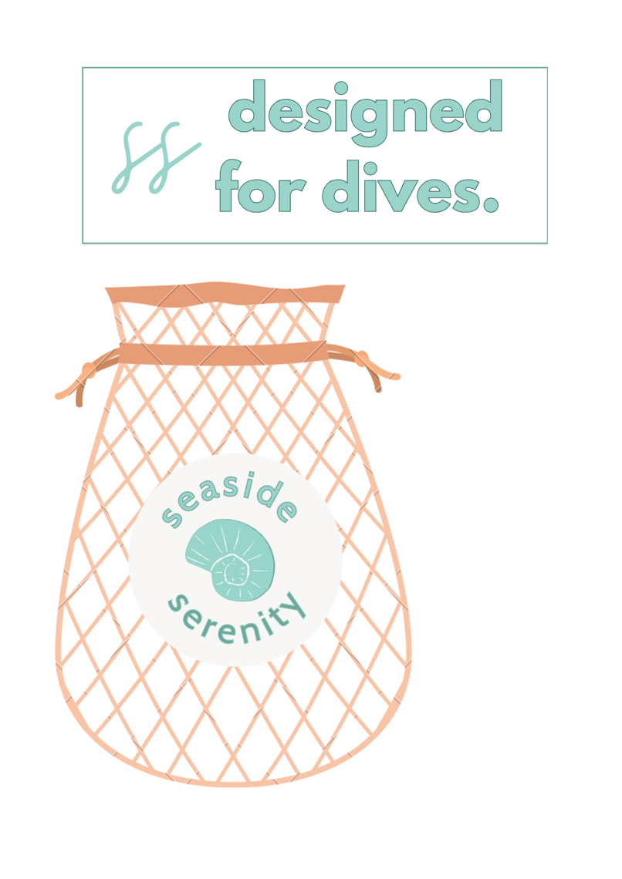

# **Phase IV**

The retail organization where the private label “Seaside Serenity” will be sold is “Sands of Style.” “Sands of Style” will have seven stores. The stores will be in California. The specific geographic location of these stores will be in Malibu, Laguna Beach, Huntington Beach, Carmel, Monterey, and La Jolla. Each store will have around 20 employees/salespeople at each location. The level of service at the retail stores will be considered luxury. Due to the higher price points of the merchandise, the beach store sells. Effective promotions will take place at the end of each season. The end-of-season sale will reduce prices by 30% to make room for more inventory. Advertising will also take place on social media and the retailer’s website. “Sands of Style” will also incorporate social responsibility into their business model. According to ASQ, “Social responsibility in business, also known as corporate social responsibility (CSR), pertains to people and organizations behaving and conducting business ethically and sensitively towards social, cultural, economic, and environmental issues. Striving for social responsibility helps individuals, organizations, and governments positively impact development, business, and society”. An example of this would be the retail organization investing in private labels such as “Seaside Serenity,” a brand with sustainable packaging. Another factor would be that “Sands of Style” promotes diversity, equity, and inclusion, ensuring all employees feel welcome and supported by the company. The retail organization also participates in and hosts beach cleanups around California, which helps get the community involved.

# **Phase V**

The items that I added to my Shopify store were all swimwear under the private label “Seaside Serenity”. I added various styles ranging from bikinis, high waisted suits and one pieces. The photographs that I got for each product were on a copyright free photo website that I learned about in my graphic design class called Pexels. In the description of each product, I made sure to credit the photographer for each piece.

Website Link: <https://0658ab.myshopify.com>

**

# **Phase VI**

The type of bag that will best serve the clients of “Seaside Serenity” is a reusable canvas tote. Due to the private label being sustainable, this type of bag fits in with the brand’s goals of fulfilling that. The straps of the bag are created out of rope which fits in with the beach theme of the brand. The “Seaside Serenity” logo is printed on the front of the bag in the center with lace trim around. The logo consists of relaxing shades of blue and cream. The lace trim adds a stylish and girly touch which fits in with the target market of the customers. Both the target customer and retail organization value sustainability so having a reusable bag is very important. The bag will not only be great for shopping but can also be multipurposed as a pool/beach bag, which fits the theme of the brand perfectly.

**Design Mockup Actual 3D Prototype**

**Bibliography**

ASQ. (2023). *What is Social Responsibility (SR)? | ASQ*. ASQ. https://asq.org/quality-resources/social-responsibility

Davis, P. (2021, November 15). *Using alliteration to create a cool company name*. Tungsten Branding. https://www.tungstenbranding.com/using-alliteration-to-create-the-perfect-company-name/

Department of Industrial Relations. (2022, October). *Hiring & Administering Employees*. Small Business Portal - Helping California’s Economy to Grow. https://www.dir.ca.gov/smallbusiness/HiringAndAdministeringEmployees.htm

*Recycled tissue paper*. EcoEnclose. (n.d.). https://www.ecoenclose.com/shop/tissue-paper/

*California’s unemployment rate increases slightly in September*. Employment Development Department. (2023, October 20). https://edd.ca.gov/en/about_edd/news_releases_and_announcements/unemployment-september-2023/

Fairlie, M. (2023, October 27). *What is a pest analysis?*. Business News Daily. https://www.businessnewsdaily.com/5512-pest-analysis-definition-examples-template.html

*Business taxes*. Internal Revenue Service. (2023, November 13). https://www.irs.gov/businesses/small-businesses-self-employed/business-taxes

U.S. Bureau of Labor Statistics. (2023, November 14). *Consumer price index, West Region - October 2023 : Western Information Office*. U.S. Bureau of Labor Statistics. https://www.bls.gov/regions/west/news-release/consumerpriceindex_west.htm

Walters, D. (2023, August 13). *While US economic outlook improves, California’s remains muddy and mediocre*. CalMatters. https://calmatters.org/commentary/2023/08/economy-outlook-improves-california-muddy/